eProject: Online Movie Booking System



ONLINE MOVIE BOOKING

SYSTEM

|  |  |  |
| --- | --- | --- |
| **Supervisor.** | Sir ABID ALI | |
| **Batch.** | PR2-20220G1 | |
| **Group.** | E-project | |
| **Serial No.** | **Enrollment Number** | **Student Name** |
| 1. | Student1370411 | DANISH HASSAN   |  | | --- | |  | |  | |

# ACKNOWLEDGEMENT

The first, we would like to express my special thanks of gratitude to my teacher << **Sir ABID ALI** >>, who helped us a lot in finalizing this project within the limited time frame, valuable counselling and assistance for the accomplishment of this project.

Secondly we would also like to thank the eProject team at Aptech Head Office, who gave us the golden opportunity to do this wonderful project about Online movie booking system.

Thirdly, we also thank the eProject team, some of the benefits are as under:

* Re-enforcement of skills happens in the experiential learning process.
* A mentor, ensuring that we do not get drifted, constantly guides us.
* It gives us a lot of confidence to face an interview as we have worked on a project. We can explain virtually everything on the subject we have learnt.

eProject: Online Movie Booking System

# Intoduction:

Watching movies is one of the entertainment medium these days. People need to surf various website to watch trailers of the movies. They need to browse through different websites to get the movie review.

Once they find a movie suited to their liking, they need to go to theatres to book ticket. For this they need to stand in queues to buy tickets.

To ease all these problems we have proposed a solution as Online Movie Ticket booking.

# Proposed Solution:

Online movie booking system is a web portal where you can book tickets in advance, know your movie show timing, watch movie trailer and read reviews for the same.

User can know everything about a movie and its show rates and show time just sitting on your couch.

Just go to web portal for Online Movie Ticket Booking System and register yourself and gain access to all the movie and theaters and many more features.

Online Movie Ticketing System in PHP is a very user-friendly project and can be accessed from anywhere.

There is no need to go to the movie theaters and wait for your turn to book movie tickets.

User can now just track everything about a movie just by clicking on to it.

User can buy tickets just by selecting a movie and show timings. Also there is three classes for a movie theatre.

User can opt to Gold, Platinum or Box class to buy tickets. These are different seat categories inside the hall.

eProject: Online Movie Booking System

# System Modules:

* The Visitors or the Registered users
* The admin (Who is responsible to update the portal)

***Role:***

***Visitor or Registered user:***

* He/she needs to first register on this web portal.
* He /she can enjoy watching trailer for movie.
* He/she can book movie ticket by selecting show time and show date.
* He/she can opt to our three classes and can select any one of the three classes.
* We have special concessions for kids (aged between 3 to 12 years).
* He/ she can read movie details and reviews along with their ratings at our web portal.

***Admin***

* Admin is the main backbone for this portal.
* Admin is responsible for adding and editing a movie theater.
* Admin will add, edit and delete movies for each movie theaters.
* Admin will be responsible for adding, editing and deleting show time for movies.
* Admin can also view the number of users that are registered to the web portal.

**Online Movie Booking system features**

* Login and Registration for users.
* View show time just by selecting your preferred date.
* Movie Reviews and ratings.
* Movie trailers.
* Payment Gateway needs to be added to this project.(Optional)
* Admin dashboard.
* Add, delete and edit movie theaters.
* Add, delete and edit movies.

Add, delete and edit shows and their rates for each classes.

# SCOPE OF THE WORK (IN BRIEF)

The website is to be developed for the Windows Platform using HTML5, CSS, BOOTSTRAP, PHP LARAVEL 9, MySQL. The site should work well in all leading browsers including Chrome, IE, Firefox etc.

# DATABASE DESIGN:

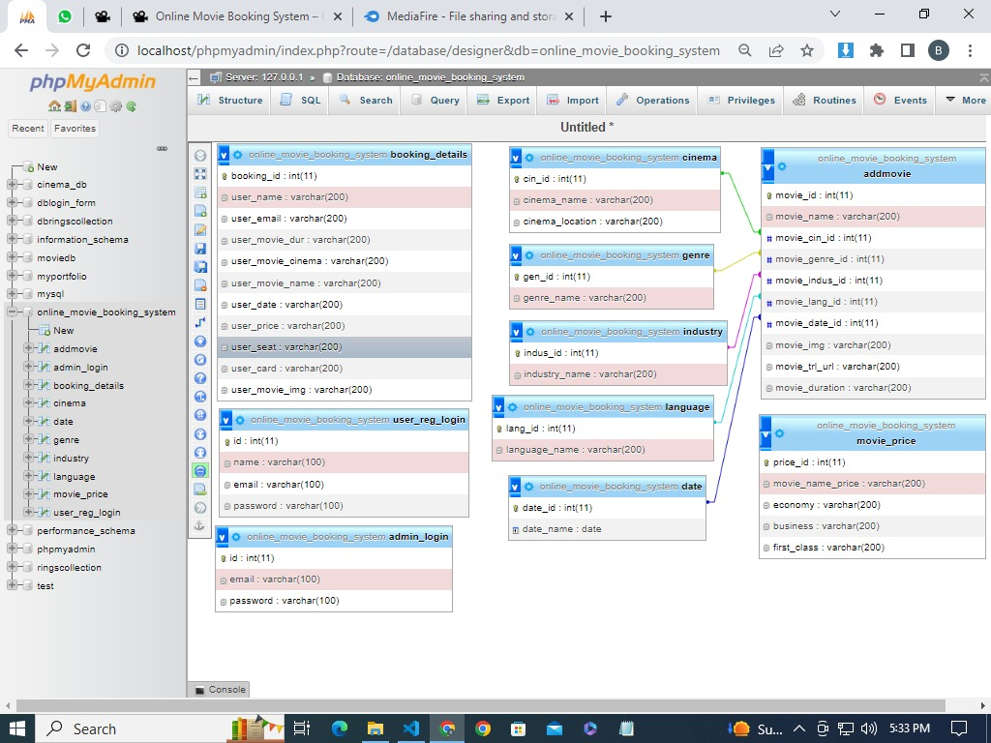

eProject: Online Movie Booking System

# HOME PAGE

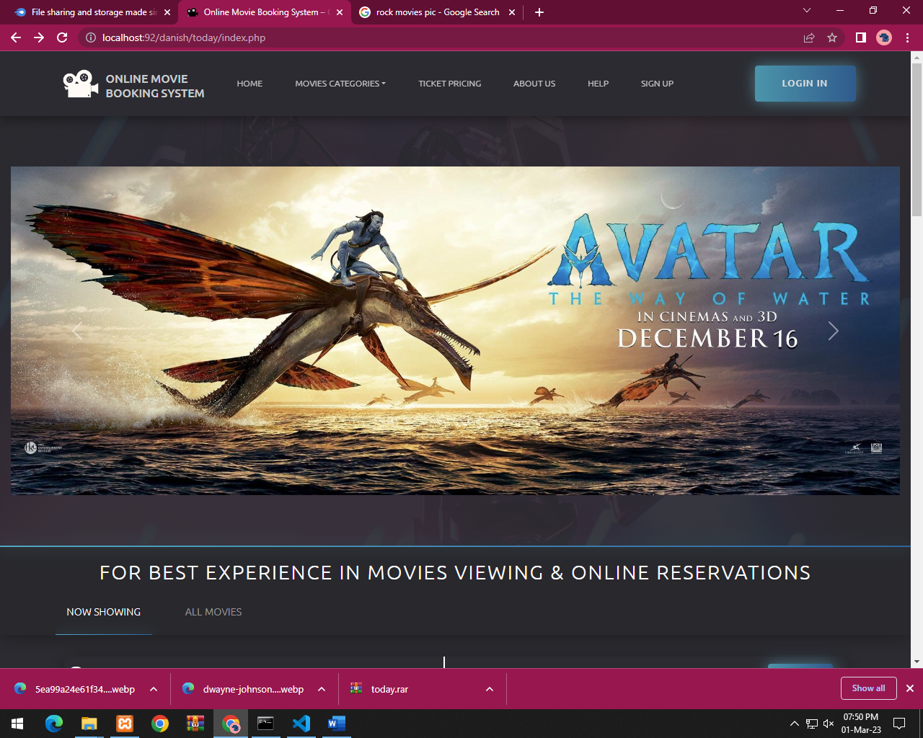

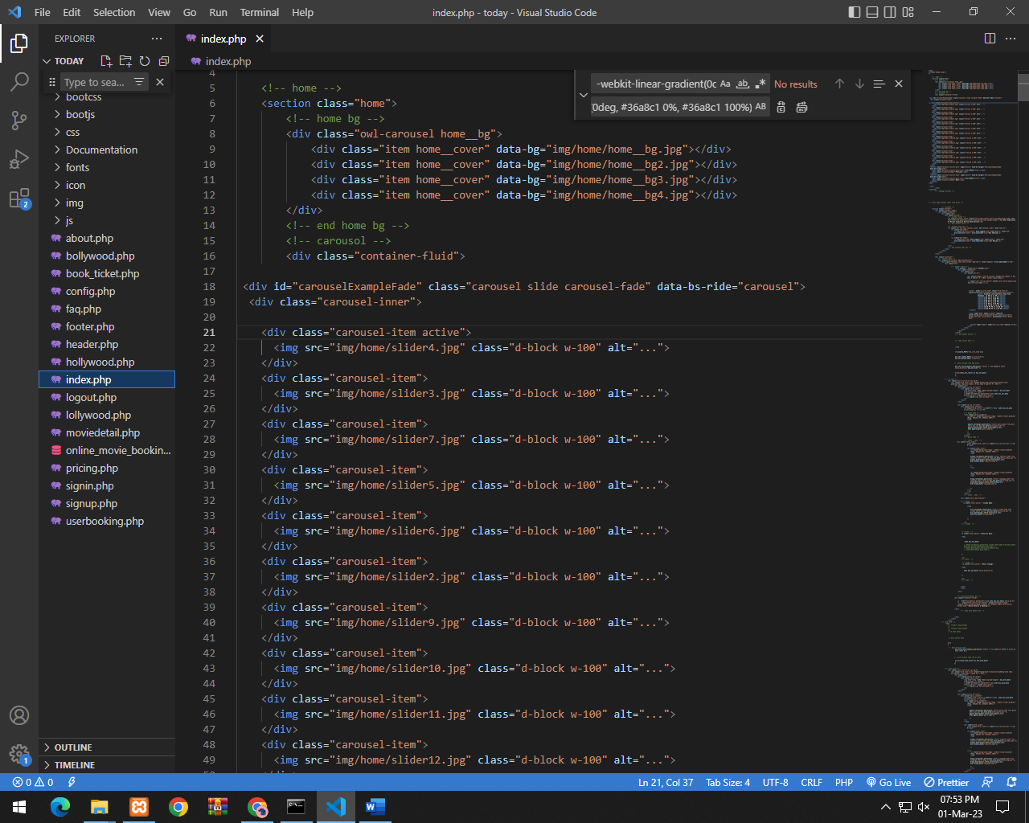

***About Us***

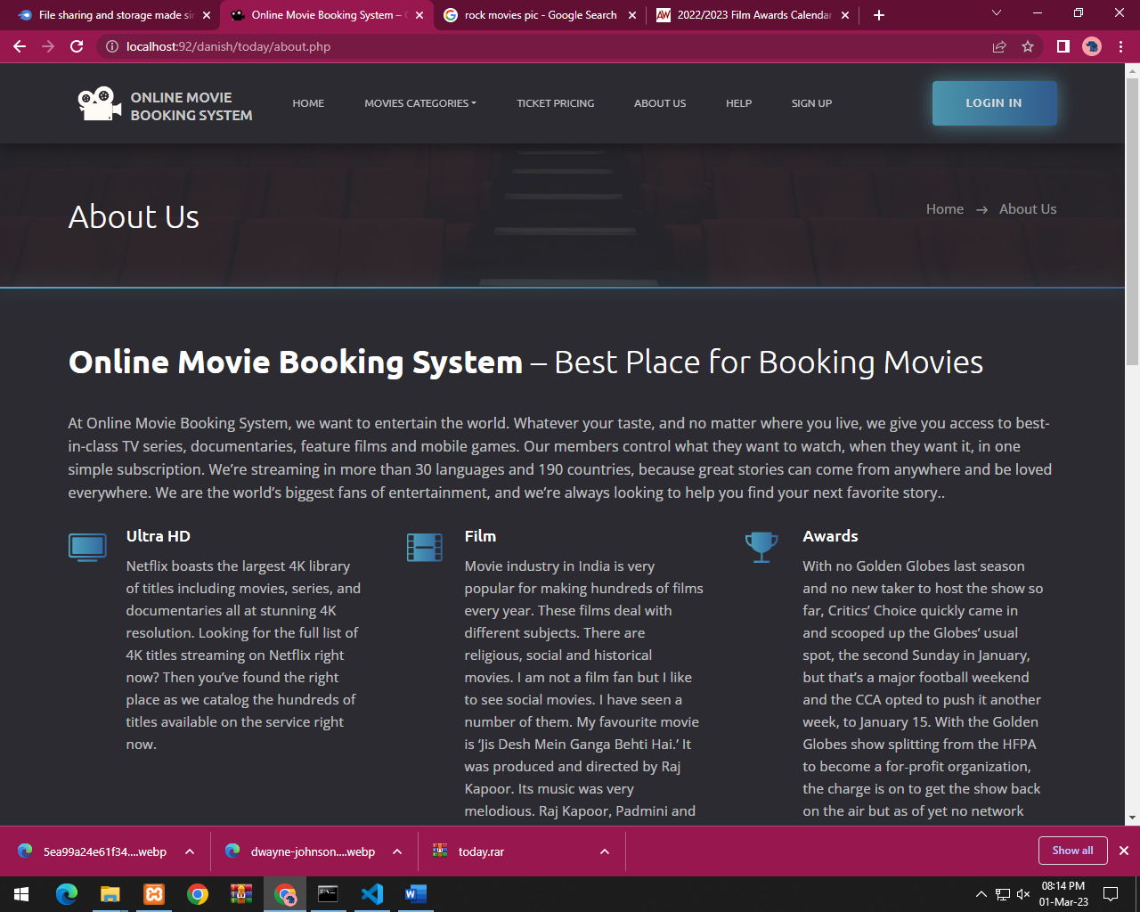

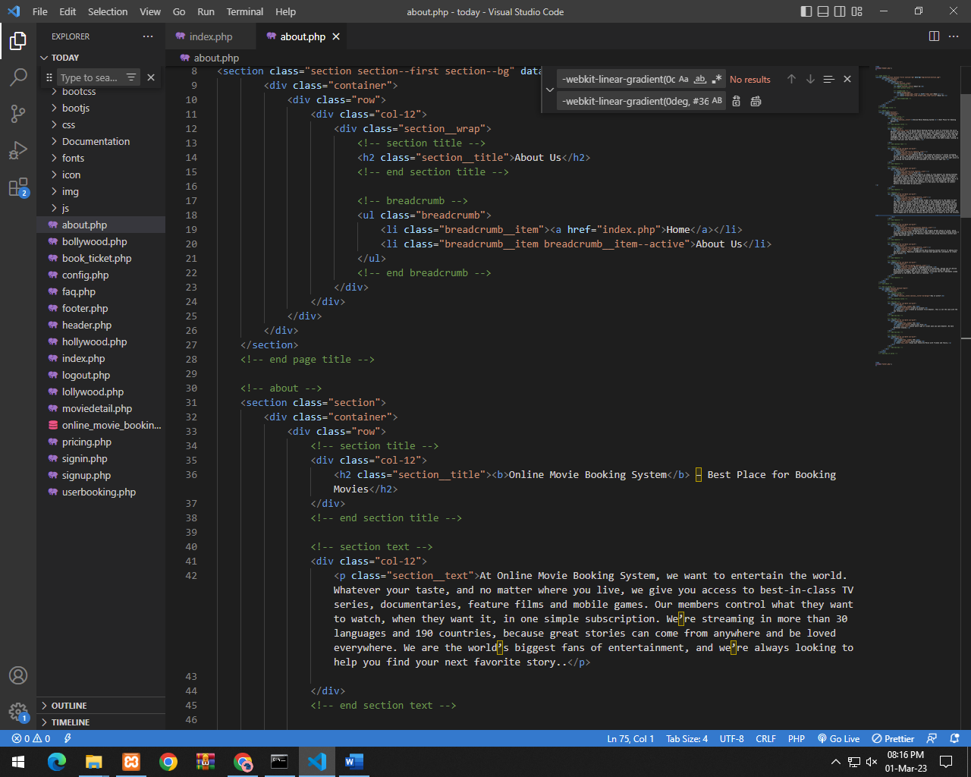

***Log In***

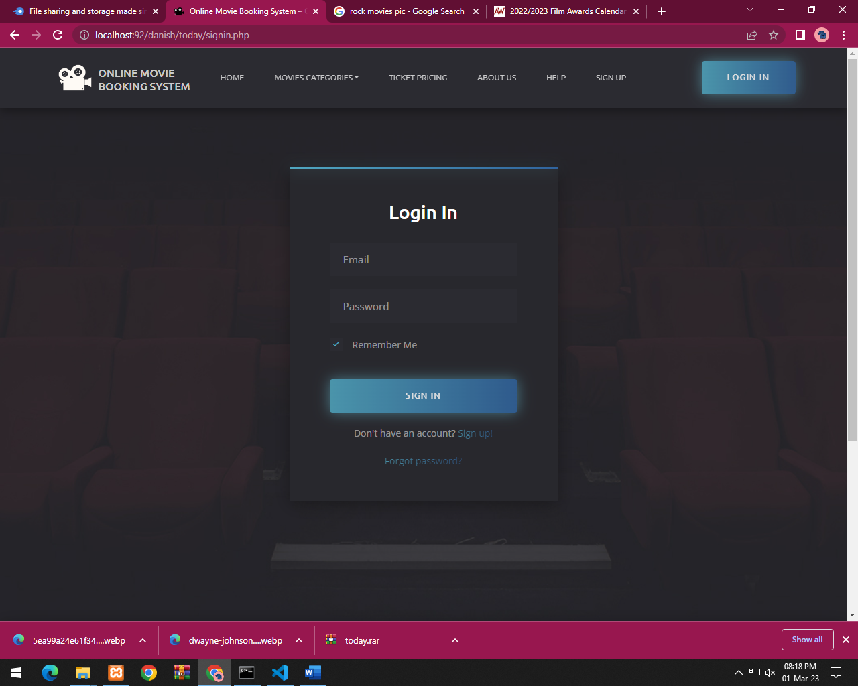

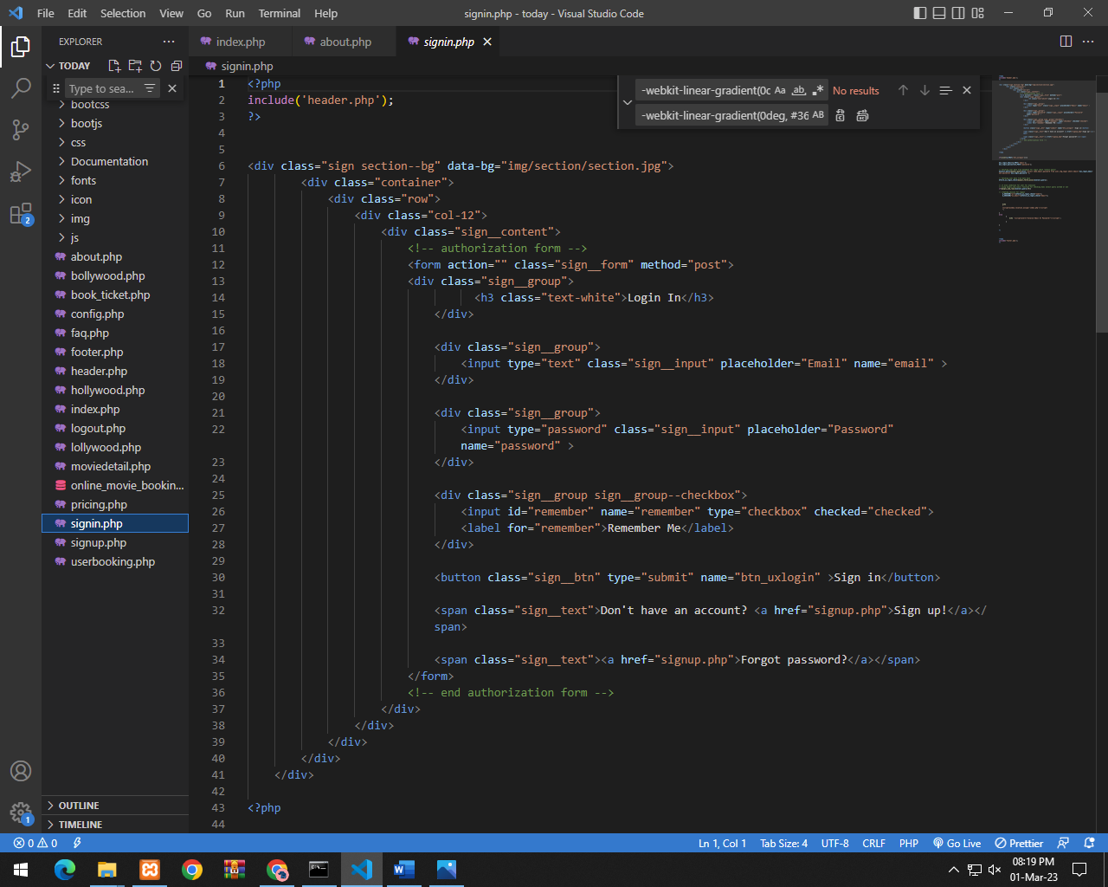

***Sign up***

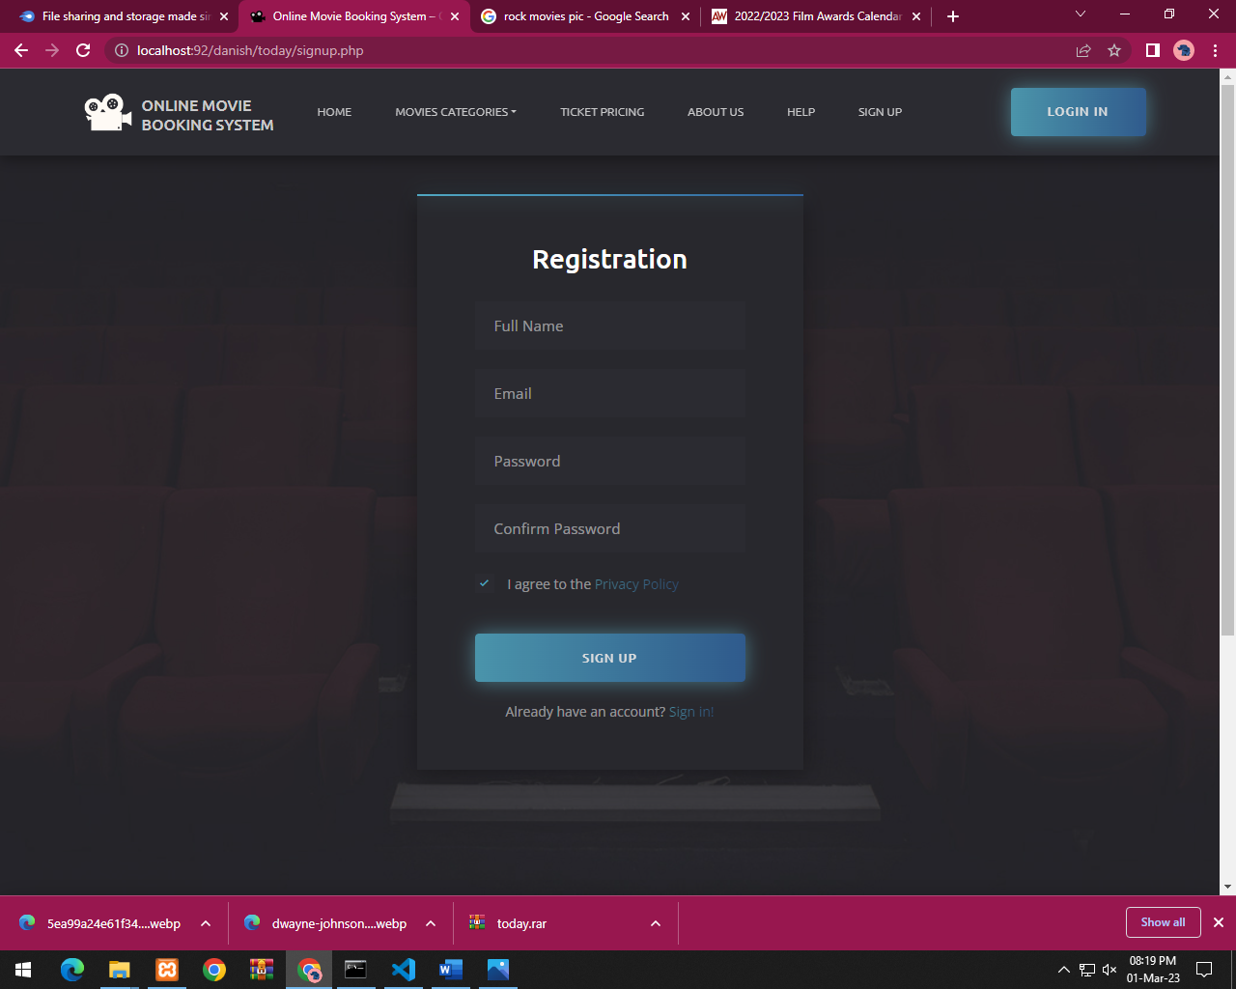

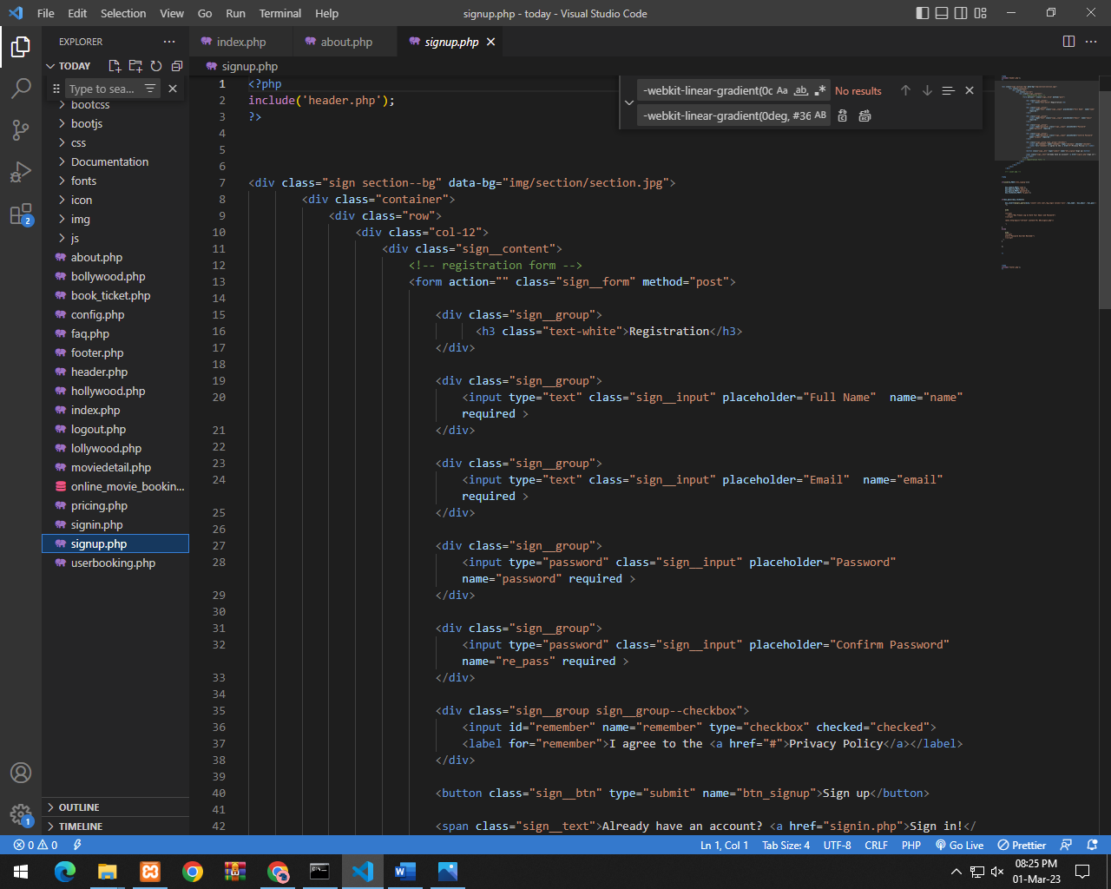

***Show Movie Detail***

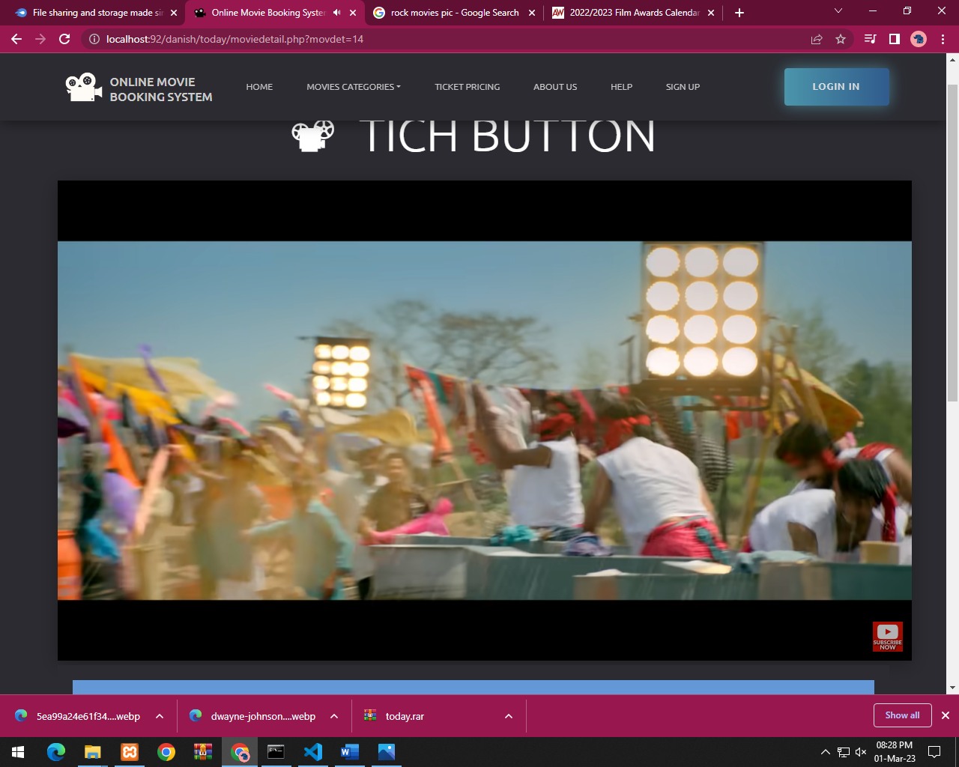

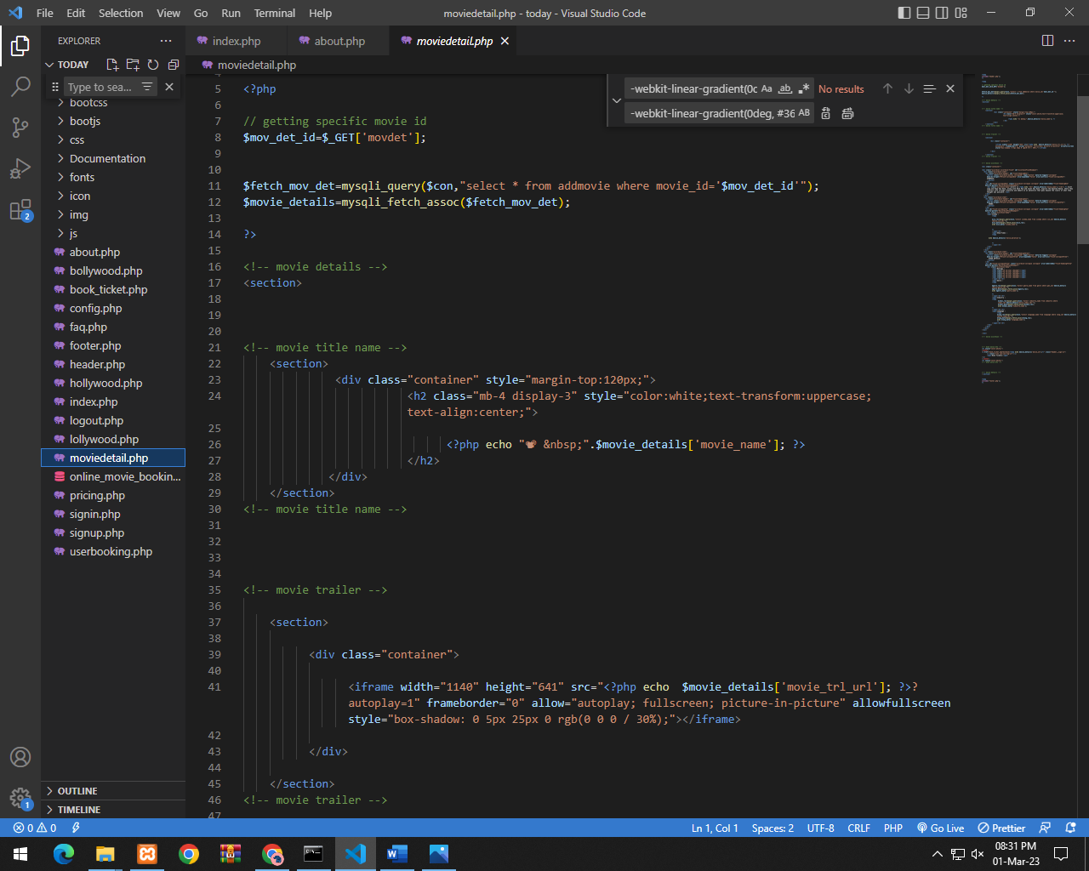

***Show Movie Booking***

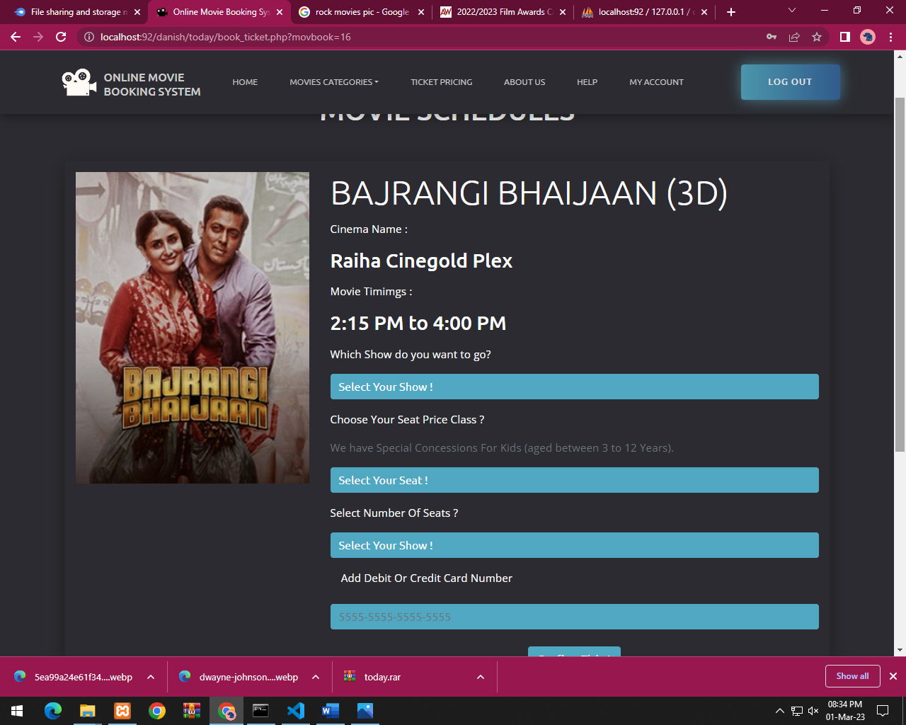

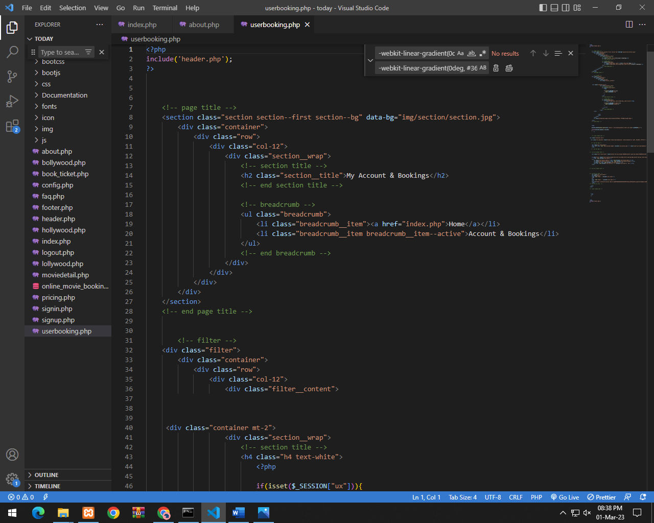

***Admin panel***

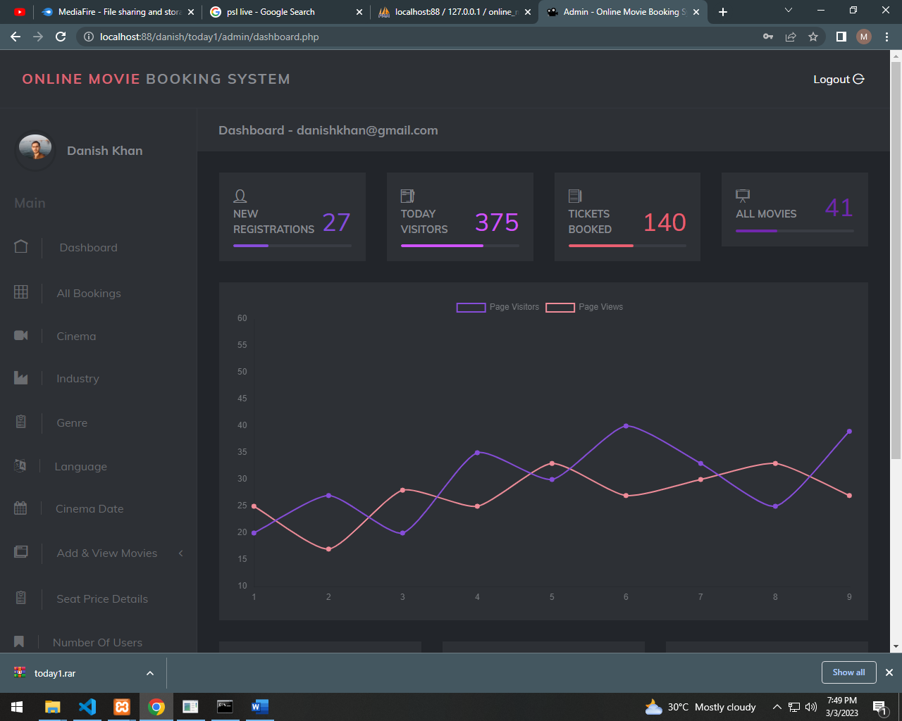

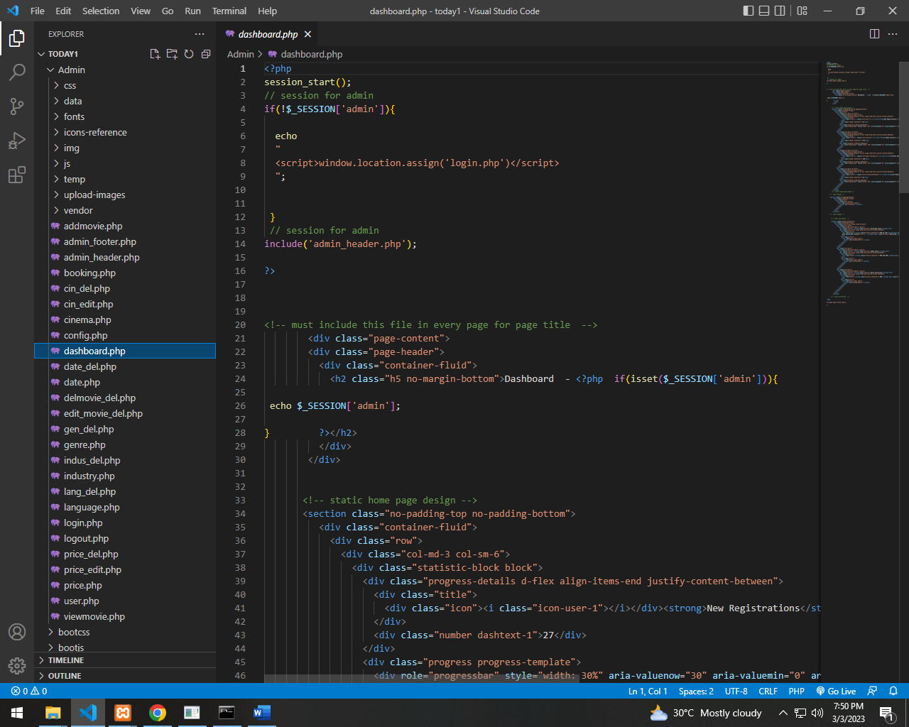

***Add Movie***

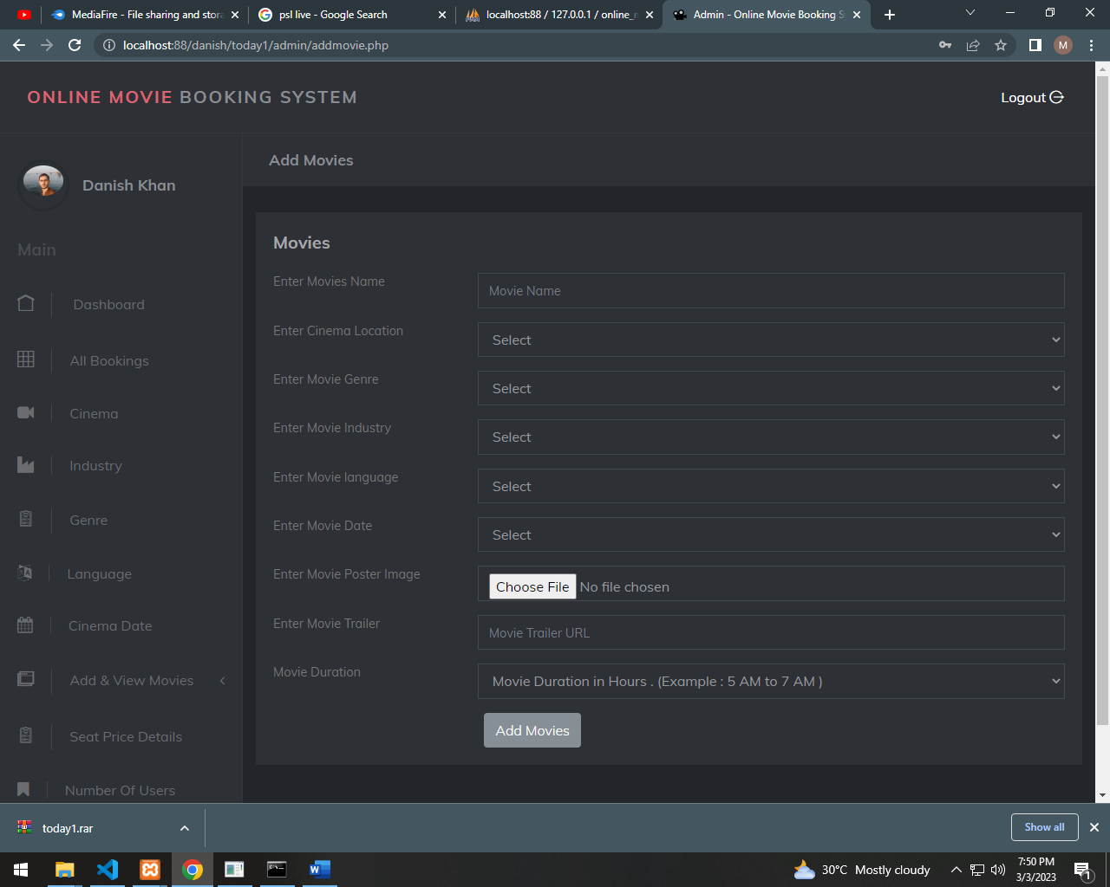

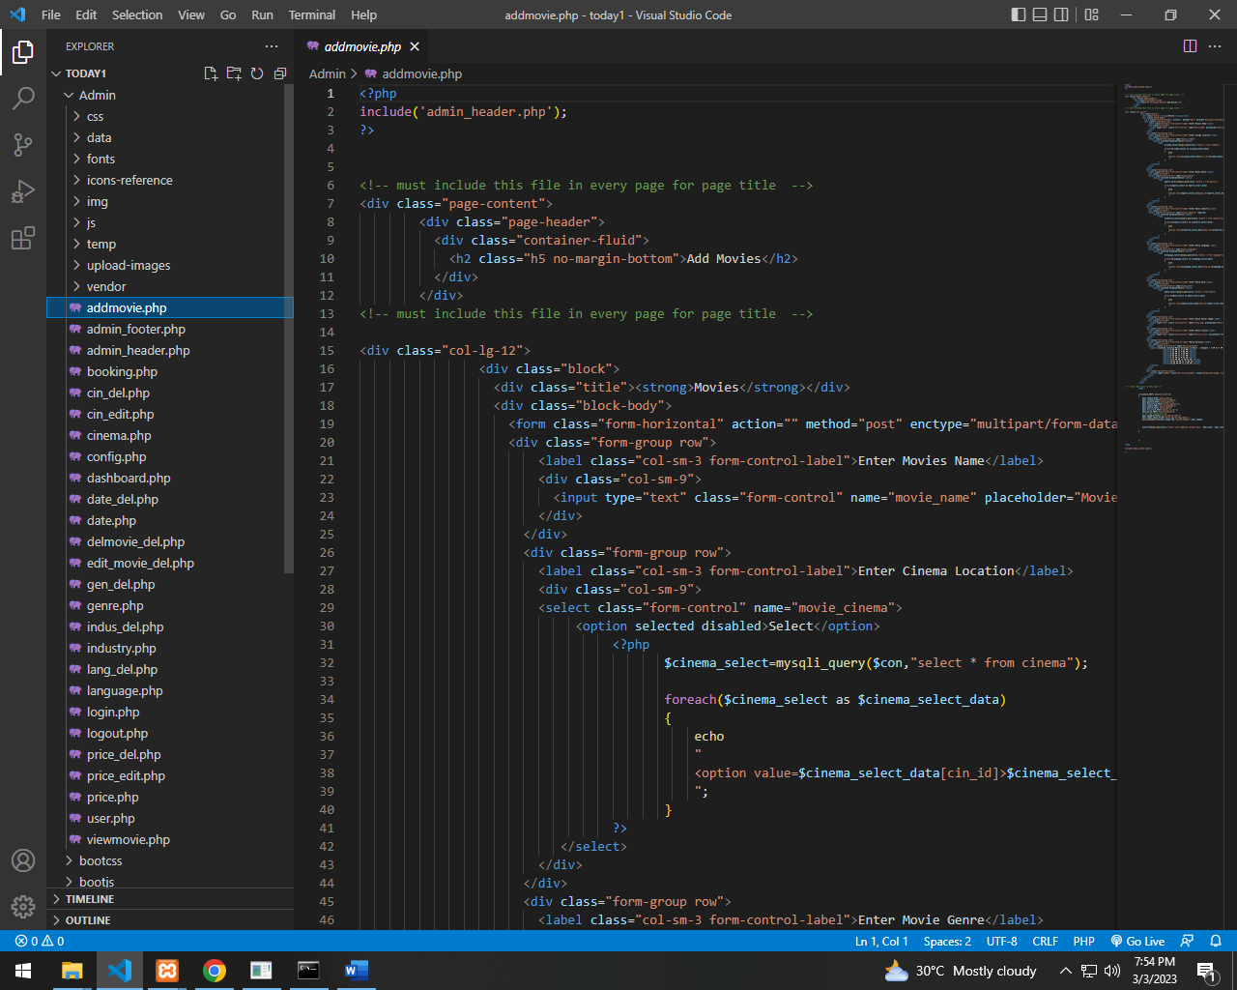

***View Movie***

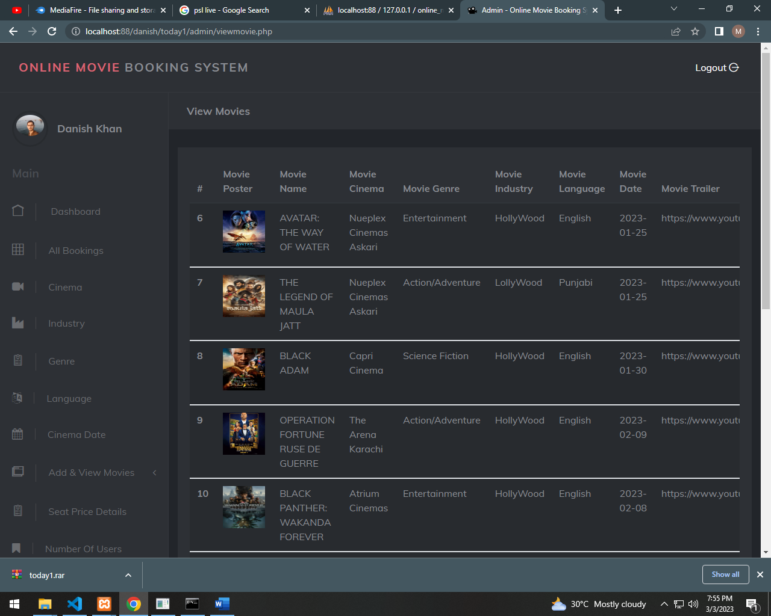

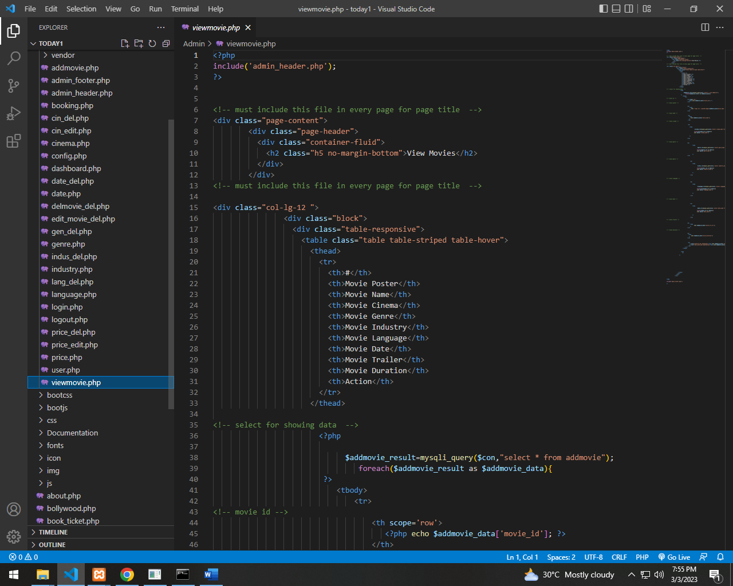

***ADD AND SHOW CINEMA***

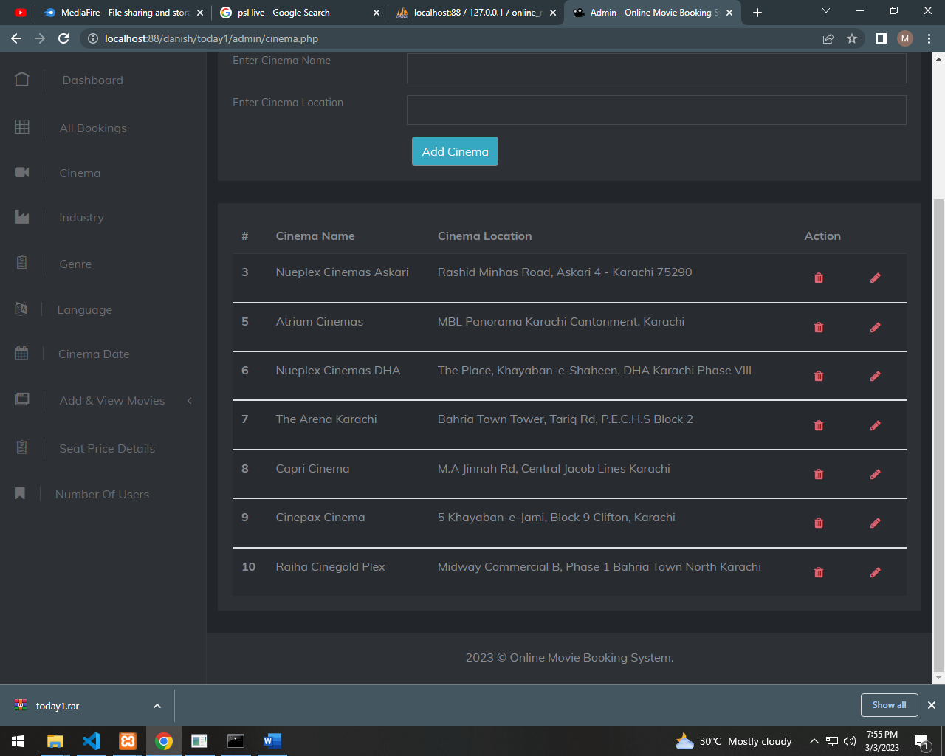

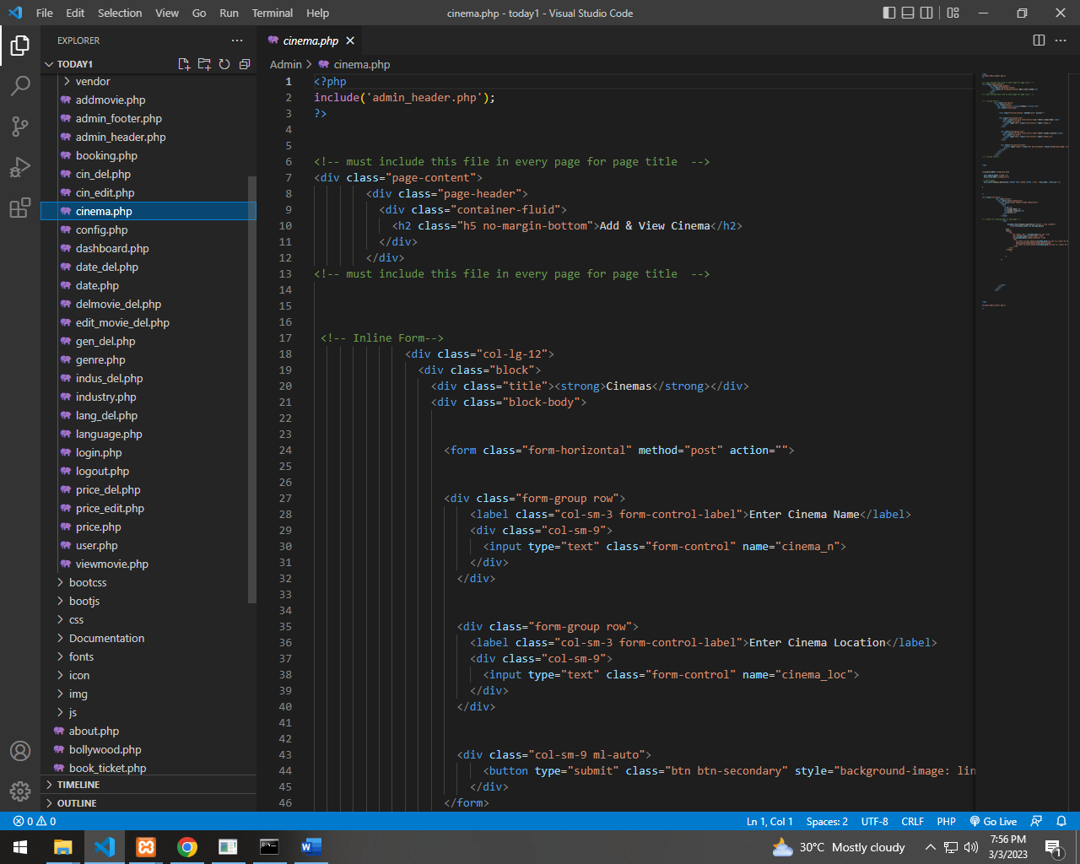

***ADD AND SHOW GENRE***

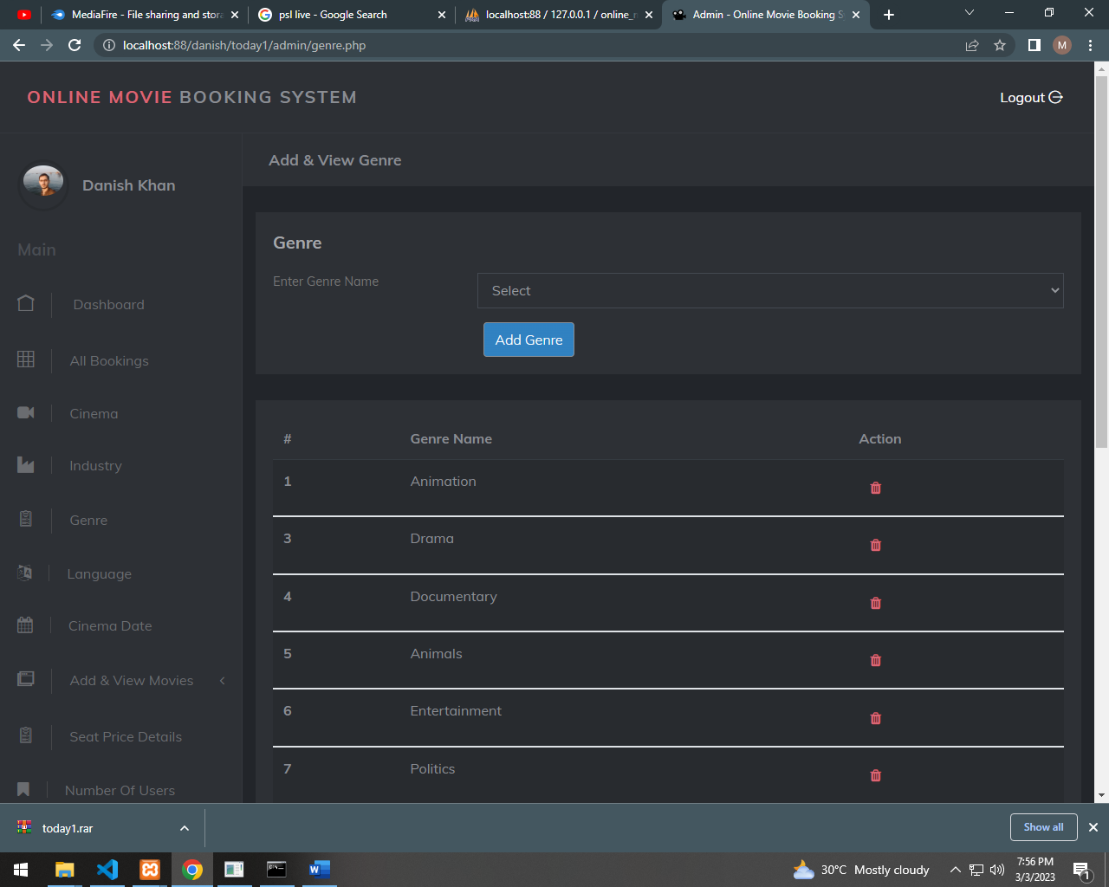

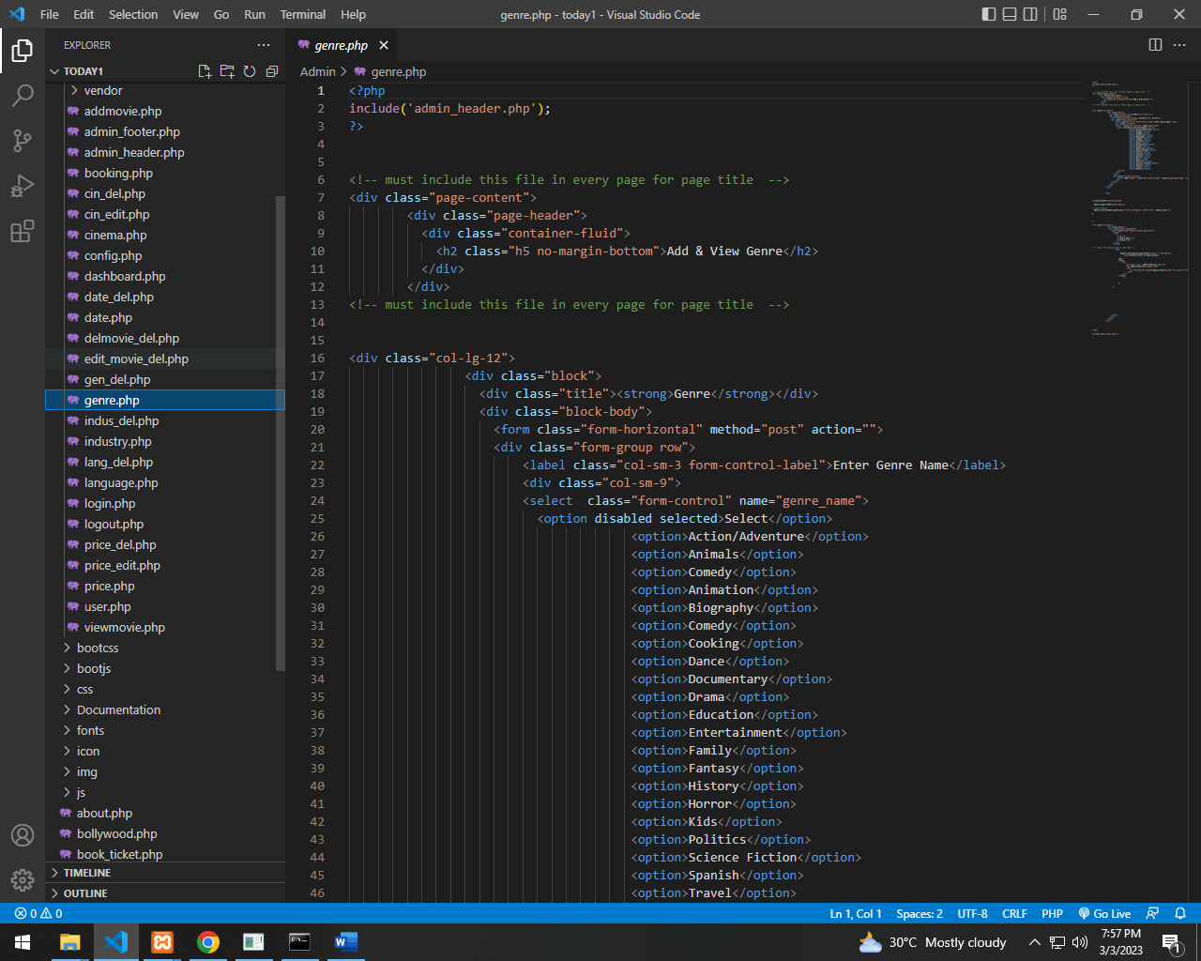

***ADD AND SHOW INDUSTRY***

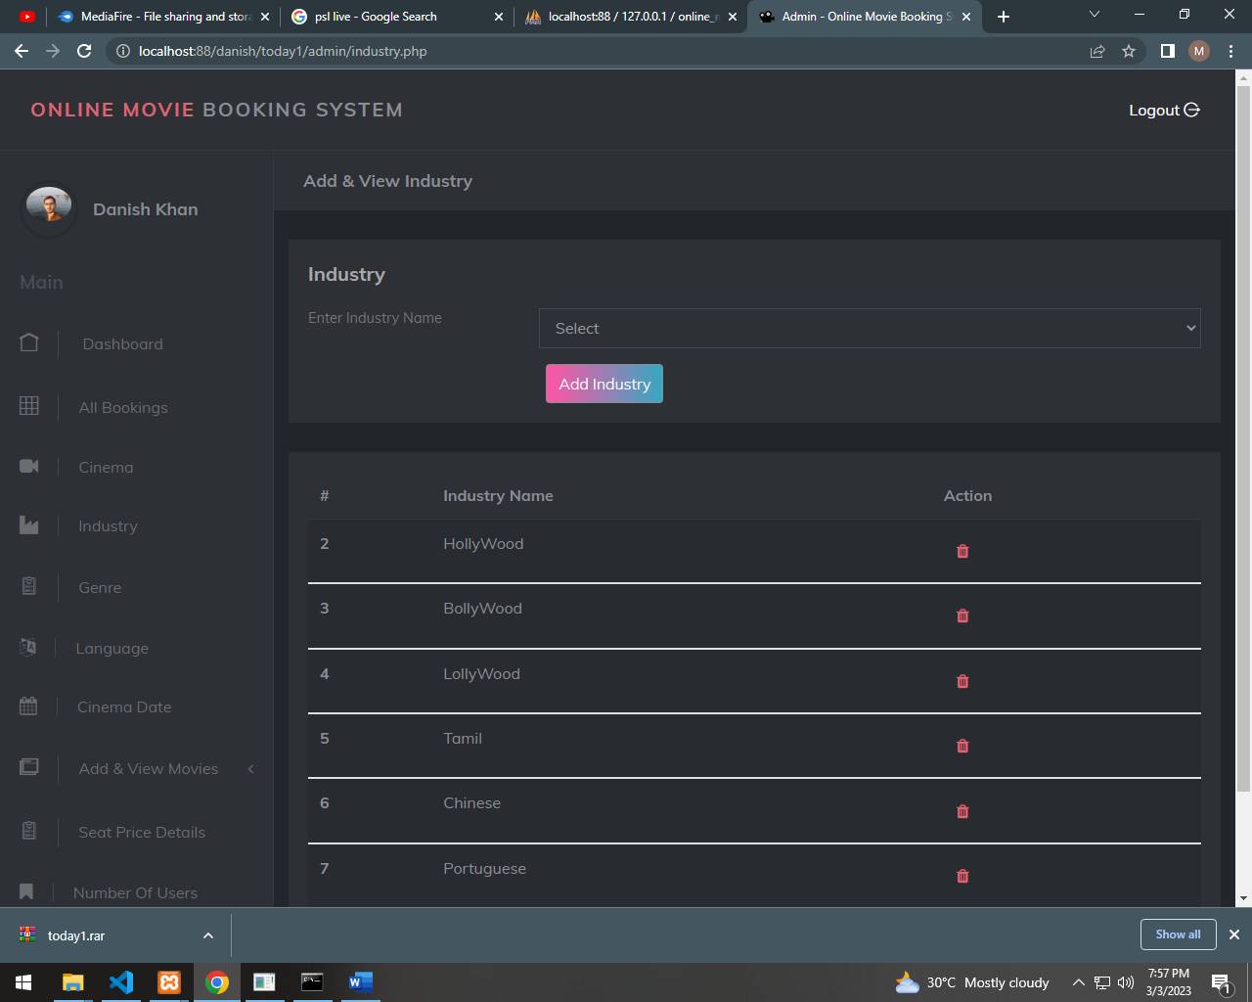

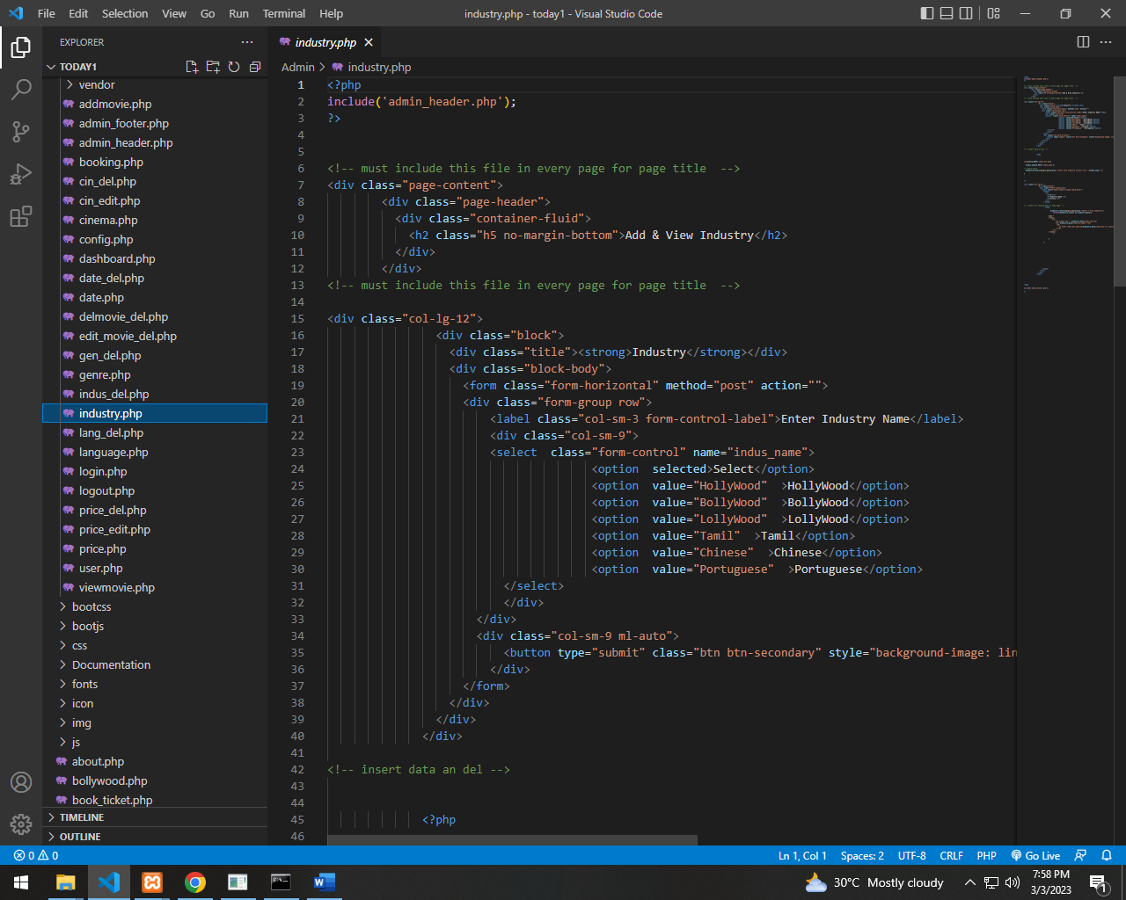

***ADD AND SHOW SEAT PRICE***

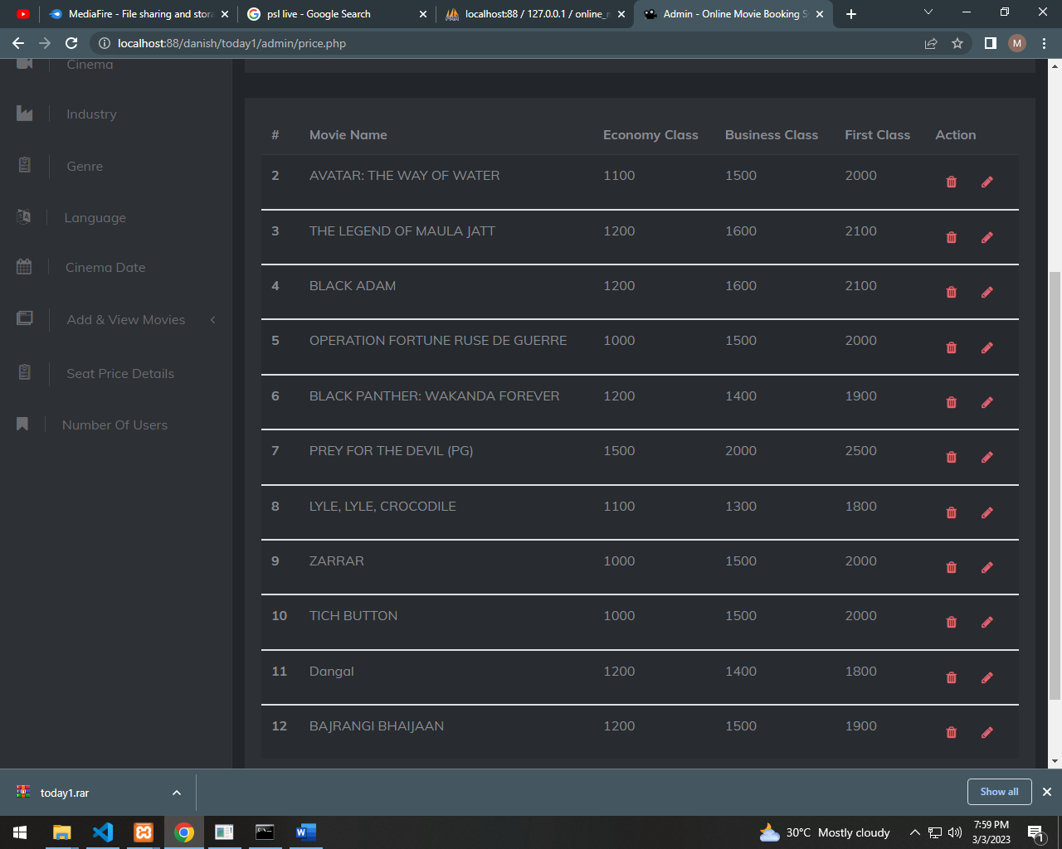

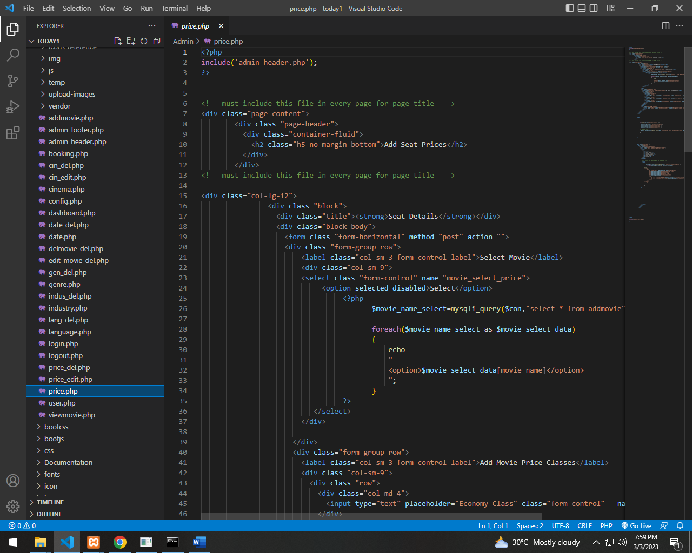

***ADD AND SHOW CINEMA DATE***

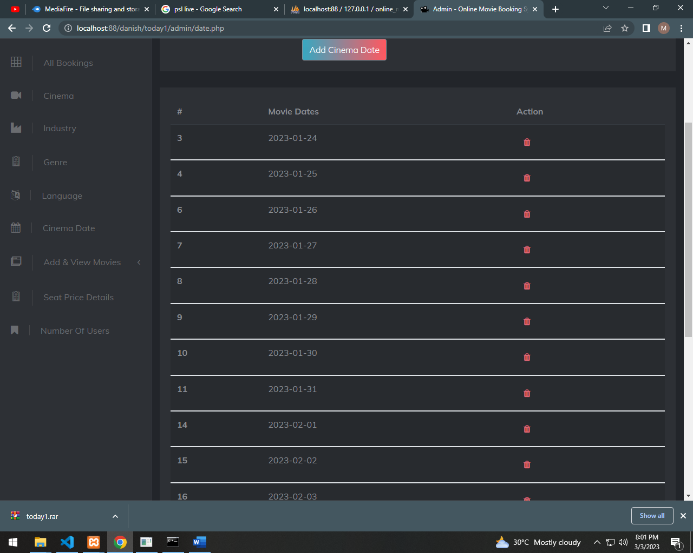

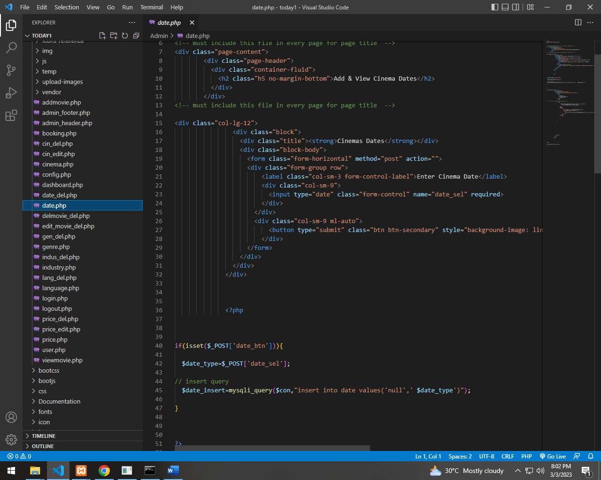

***SHOW ALL BOOKINGS***

